

MATHEMATICS DRAFT SAMPLE EXAMINATION

UNITS 3AMAS/3BMAS

Section 7 of the WACE Manual: General Information 2008 Revised Edition outlines the policy on WACE examinations.

Further information about the WACE Examinations policy can be accessed from the Curriculum Council website at http://www.curriculum.wa.edu.au/internet/Communications/Publications/.

The purpose for providing a sample examination is to provide teachers with an example of how the course will be examined.

Each WACE mathematics examination will comprise a calculator-free Section One and a calculator-assumed Section Two.

Section One and Section Two will be printed separately with different coloured front covers. Section One will contain a perforated page of formulas particular to that examination, which will be retained for possible use in Section Two.

2008/37889[2]

Copyright
© Curriculum Council, 2008
This document—apart from any third party copyright material contained in it—may be freely copied, or communicated on an intranet, for non-commercial purposes by educational institutions, provided that it is not changed in any way and that the Curriculum Council is acknowledged as the copyright owner.
Copying or communication for any other purpose can be done only within the terms of the Copyright Act or by permission of the Curriculum Council.
Copying or communication of any third party copyright material contained in this document can be done only within the terms of the Copyright Act or by permission of the copyright owners.





WACE Draft Sample Examination 2008

Question/answer booklet

MATHEMATICS
Please place your student identification label in this box
3AMAS/3BMAS

Section One
(calculator-free)

Student Number: In figures

In words

Time allowed for this section
Section One
Reading time before commencing work: five minutes
Working time for paper: 50 minutes

Material required/recommended for this paper

To be provided by the supervisor
Question/answer booklet for Section One, containing a removable formula sheet which may also be used for Section Two

To be provided by the candidate
Section One:
Standard items: pens, pencils, pencil sharpener, highlighter, eraser, ruler

Important note to candidates
No other items may be taken into the examination room. It is your responsibility to ensure that you do not have any unauthorised notes or other items of a non-personal nature in the examination room. If you have any unauthorised material with you, hand it to the supervisor before reading any further.
Structure of this examination

 | Number of questions available | Number of questions to be attempted | Suggested working time (minutes) | Marks available
Section One  Calculator-free | 8 | 8 | 50 | 40
Section Two  Calculator-assumed |  |  | 100 | 80
Total marks |  |  |  | 120

Instructions to candidates

- The rules for the conduct of WACE external examinations are detailed in the booklet WACE Examinations Handbook. Sitting this examination implies that you agree to abide by these rules.

- Answer the questions in the spaces provided.

- Spare answer pages are provided at the end of this booklet. If you need to use them, indicate in the original answer space where the answer is continued i.e. give the page number.

Section One (calculator-free)

This section has eight (8) questions. Attempt all questions.

Suggested working time: 50 minutes.

Question 1 (4 marks)
Simplify the following:
  - 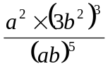 (2 marks)

  - 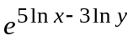 (2 marks)

Question 2 (5 marks)
Find the real and complex parts of the following complex numbers:
  - 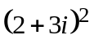 (2 marks)

  - 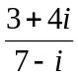 (2 marks)

  - 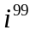 (1 mark)

Question 3 (4 marks)
Find all values of in the interval 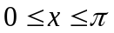 that satisfy the equation
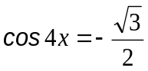

Question 4 (6 marks)
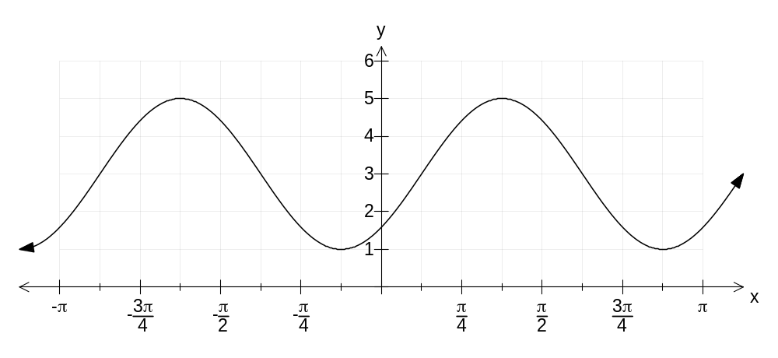Part of the graph of the function 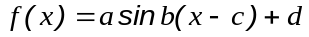is shown below. Use the graph to evaluate the constants a, b, c and d, given that 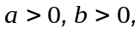 and 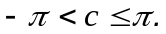

Question 5 (4 marks)
Find the derivatives of the following functions. It is not necessary to simplify your answers.
  - 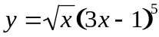 (2 marks)

  - 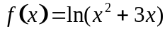 (2 marks)

Question 6 (5 marks)
Given that tan A = 3 and tan (A + B) = -7, find tan B.

Question 7 (6 marks)
  - The number line below shows the solution set of the inequality 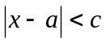.
Determine the values of a and c. (2 marks)

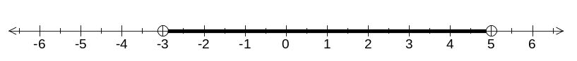

  - Solve the inequality 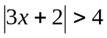. (4 marks)

Question 8 (6 marks)
The functions 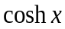 and 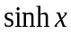are defined by
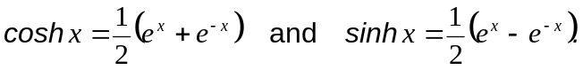
  - Show that 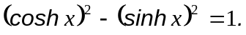 (3 marks)

  - Show that 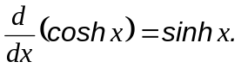 (1 mark)

  - Use your knowledge of the graphs of 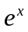 and 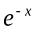 to sketch the graph of 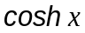.
(2 marks)

Sample formula sheet 3AMAS/3BMAS

Vectors
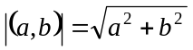, 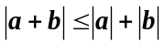
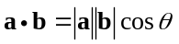 = 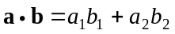
vector equation of a line in the plane
one point and the slope: r = r₁ + λ l, two points: r = r₁ + λ (r₂ – r₁ )₋, normal:
vector form of the equation of a circle in the plane: 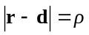

Trigonometry
In any triangle ABC
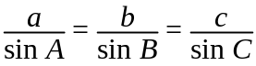 , 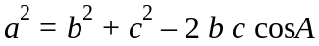, 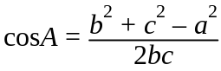 and Area = 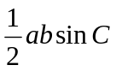

In a circle of radius r, for an arc subtending angle  (radians) at centre,
length of arc = rP, area of sector = ½ r²P, area of segment = ½ r²(P - sin P)

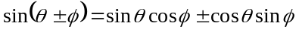  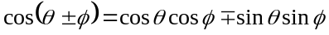  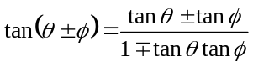 | 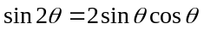  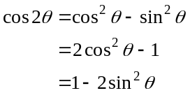  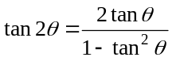

Exponentials and logarithms
For 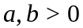 and 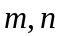 real
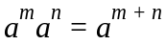 , 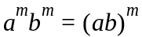 , 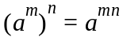 , 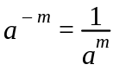 , 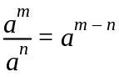 , 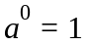
For m an integer and n a positive integer 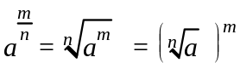

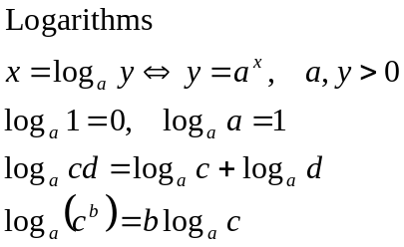

(see over)

Functions
Derivatives
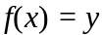 | 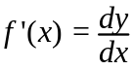
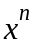 | 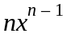
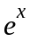
ln x

Product rule | 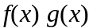 | 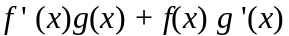 | 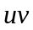 | 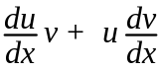
Quotient rule | 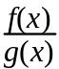 | 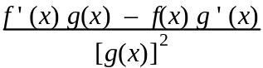 |  | 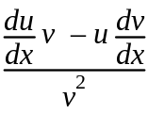
Chain rule | 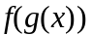 | 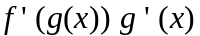 | 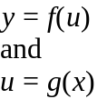 | 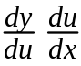

Piece-wisedefined functions
Absolute value function: 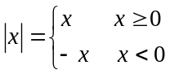
Sign function: 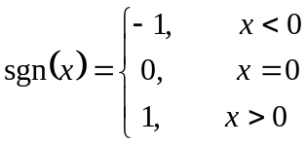
Greatest integer function: 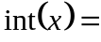 greatest integer ≤ x for all x

Measurement
Trapezium: 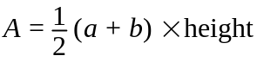 where a and b are the lengths of the parallel sides
Prism: V = area of base × height
Pyramid: V = area of base × height
Cylinder: Total surface area = 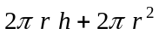 Volume 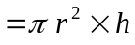
Cone: Total surface area = 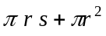, s is the slant height Volume 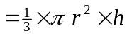
Sphere: Total surface area = 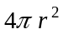 Volume 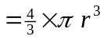
Published by the Curriculum Council of Western Australia
27 Walters Drive
OSBORNE PARK WA 6017

WACE, Draft Sample Examination 2008

Question/answer booklet

MATHEMATICS
Please place your student identification label in this box
3AMAS/3BMAS

Section Two
(calculator-assumed)

Student Number: In figures

In words

Time allowed for this section
Section Two
Reading time before commencing work: ten minutes
Working time for paper: 100 minutes

Material required/recommended for this paper

To be provided by the supervisor
Question/answer booklet for Section Two. Candidates may use the removable formula sheet from Section One

To be provided by the candidate
Section Two:
Standard items: pens, pencils, pencil sharpener, highlighter, eraser, ruler
Special items: drawing instruments, templates, notes on up to two unfolded sheets of A4 paper, and up to three calculators, CAS, graphic or scientific, which satisfy the conditions set by the Curriculum Council for this course.

Important note to candidates
No other items may be taken into the examination room. It is your responsibility to ensure that you do not have any unauthorised notes or other items of a non-personal nature in the examination room. If you have any unauthorised material with you, hand it to the supervisor before reading any further.
Structure of this paper

 | Number of questions available | Number of questions to be attempted | Suggested working time (minutes) | Marks available
Section One  Calculator—free |  |  | 50 | 40
Section Two  Calculator—assumed | 12 | 12 | 100 | 80
Total marks |  |  |  | 120

Instructions to candidates

- The rules for the conduct of WACE external examinations are detailed in the booklet WACE Examinations Handbook. Sitting this examination implies that you agree to abide by these rules.

- Answer the questions in the spaces provided.

- Spare answer pages are provided at the end of this booklet. If you need to use them, indicate in the original answer space where the answer is continued i.e. give the page number.
Section Two: Calculator – assumed 80 marks

This section has twelve (12) questions. Attempt all questions.

Suggested working time: 100 minutes.

Question 1 (8 marks)
An orienteer runs 2 km in a north-easterly direction. He then runs 4.5 km due west, followed by 3.6 km at a bearing of 135 degrees i.e. 45 degrees east of south. He now wants to return directly to his starting point.

Use vector methods to determine:
  - the direction in which he should run;
  - his distance from the starting point.

Question 2 (4 marks)
  - Find the acute angle between the lines  and 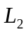 where:
: r = 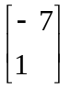 + λ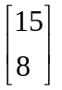 : r . 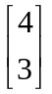 = 19

Give your answer in degrees correct to 2 decimal places. (2 marks)

  - Does the line pass through the origin? Justify your answer. (2 marks)

Question 3 (5 marks)
Perth lies on Latitude 32° South. Given that the radius of the earth is 6350 km:
  - Find, to the nearest km, the circumference of the circle through which Perth passes during one rotation of the earth on its axis. (2 marks)

  - Calculate Perth’s velocity in km/h. (1 mark)

  - Comment, without calculation, on how Perth’s velocity would compare with that of Jakarta, where the latitude is 6° South. Explain your answer. (2 marks)

Question 4 (5 marks)
A and B have polar coordinates (1, α) and (1, β) respectively, where 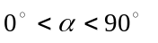and 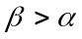.

  - State the coordinates of A and B in Cartesian form. (2 marks)

  - Write down the scalar product 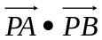 (where P is the pole):
    - using the components of the two vectors;

    - using the magnitudes of the vectors and the angle between them. (2 marks)

  - Hence deduce a formula connecting α and β. (1 mark)

Question 5 (4 marks)
Jodie is following a weight-loss program and loses 1% of her weight every week. Jodie’s friend Kevin is following an even stricter weight-loss program and loses 2% of his weight every week. If Jodie and Kevin begin their programs at the same time, and Kevin is initially 25% heavier than Jodie, how long will it take until Jodie and Kevin have the same weight?

Question 6 (9 marks)
Julie paddles her kayak in a body of water which is flowing in a south-easterly direction at a speed of 2 km/h. Her speed in still water is 5 km/h.

  - If Julie paddles due north, in what direction and at what speed does the kayak actually travel? Support your answer with a diagram. (4 marks)

  - If Julie wants to travel due north, in what direction should she paddle her kayak, and how fast would she actually travel? Support your answer with a diagram. (5 marks)

Question 7 (9 marks)
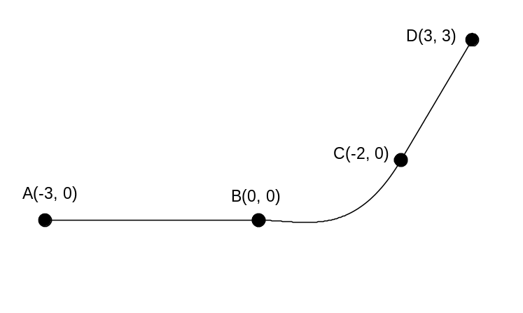The curve ABCD consists of straight line segments AB and CD, and an arc BC whose equation is a cubic polynomial 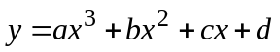

The coordinates of A, B, C and D are as shown in the diagram.

  - Show that if the curve and its derivative are continuous at B, then c = 0 and d =0
(2 marks)

  - Evaluate a and b, given that the curve and its derivative are continuous at C.
(3 marks)

  - Where on the curve does the greatest change in the second derivative occur?
(4 marks)

Question 8 (7 marks)
The approximation 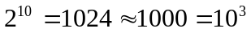can be used as a starting point for building a table of estimates of base-10 logarithms.

  - Take logarithms of both sides of the approximation 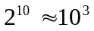 to show that 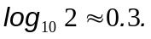
(1 mark)

  - Use the estimate 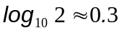 to estimate 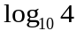 and 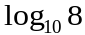. (1 mark)

  - Now use the approximation 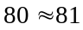 to estimate 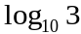 correct to 1 decimal place. (1 mark)

  - Use your existing results to estimate 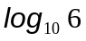. (1 mark)

  - The interval [1, 9] can be subdivided into 4 equal sub-intervals. Use your estimates of to estimate 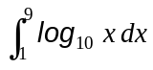. (3 marks)

Question 9 (12 marks)
The function f is defined by the formula
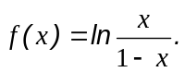
  - What is the domain of the function f? (2 marks)

  - Sketch the graph of f. (2 marks)

  - Use the graph of f to determine its range. (1 mark)

  - Use your calculator to find the equation of the tangent to f at 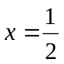. (2 marks)

  - Use your sketch of the graph of f to sketch the graph of the inverse 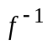. (2 marks)

  - What are the domain and range of 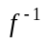? (2 marks)

  - If 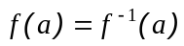 what is the value of a? (1 mark)

Question 10 (4 marks)
A major sector of a circle has an area of 88 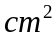. If the sector also has a perimeter of 38 , determine, exactly, the length of the radius and the angle (in radians) described by the sector.

Question 11 (6 marks)
The centre of a circle, 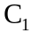, has position vector 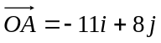. The radius of the circle is 15 units.

  - State the vector equation of . (1 mark)

The centre of a second circle, 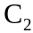, has position vector 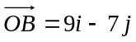; its radius is 10 units. If 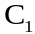 and were drawn on a calculator they would appear to touch.

  - Demonstrate mathematically that and do in fact touch. (2 marks)

P is the point of contact between the two circles.
  - Use the fact that 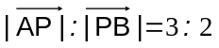 to determine the coordinates of P. (3 marks)

Question 12 (7 marks)
Use trigonometric identities to prove that:
  - 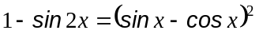 (3 marks)

  - 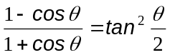 (4 marks)

THIS PAGE HAS BEEN LEFT BLANK INTENTIONALLY

ACKNOWLEDGEMENTS
Published by the Curriculum Council of Western Australia
27 Walters Drive
OSBORNE PARK WA 6017

